Alpha Chi Omega

Ashley Malone
Kansas State University – BA Criminology minor Spanish

Ashley Malone has been passionate about Alpha Chi Omega since her collegiate days. While at K-State, she served as president of the Gamma Zeta chapter. She has also served in several local and national roles including Province Alumnae Chair (Kansas, Oklahoma and Nebraska); Alumnae Engagement Task Force Chair; Alumnae Resource team member – Alpha Kindness Chair; Mu Mu Alumnae Recruitment Chair; Gamma Zeta Ritual/Fraternity Appreciation Advisor; Gamma Zeta House Corporation Board Communications Committee Chair. Ashley is currently employed with DineEquity, the parent company of Applebee’s & IHOP in Human Resources. She recently relocated to their headquarters in Los Angeles. Ashley also enjoys working out, and volunteering.

Alpha Delta Pi

Kimberly Seten
Undergraduate – University of Illinois at Urbana-Champaign
University of Miami School of Law

Kim is a Managing Partner at Constangy, Brooks Smith & Prrophete, LLP where she practices Labor Law. She focuses her practice on helping clients proactively address workplace manners. Kim is a frequent contributor and presenter nationally. She recently served as the Chair of the prestigious Heartland Labor and Employment Institute.
Kim has been active in Alpha Delta Pi, including membership in the Kansas City North Alumnae Association. She currently serves as an International Officer of Alpha Delta Pi as Province Director. Previously, Kim was Chapter Advisor at the Chapter at William Jewell College.
Kim and her husband, Matt, have two children, and they enjoy spending time at their kids’ extracurricular activities as well as cheering on Kansas City’s sports teams.

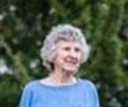
Alpha Gamma Delta

Charlene Conrad
University of Missouri – Bachelor of Science in Education

Charlene is a 50+ year member of the Greater Kansas City Alumnae Club of Alpha Gamma Delta. She has served the club in every possible role, usually multiple times, and continues of offer her time and enthusiasm. She is the world’s best role model for younger members. Charlene served her greater community on the Overland Park Planning Commission as a mayoral appointee for 20 years, and currently volunteers for the Overland Park Historical Society.

Alpha Omicron Pi

Kate Favrow
University of Illinois at Urbana-Champaign – Bachelors of Sciences Marketing
University of Kansas – Master’s in Business Administration & Marketing

Kate’s involvement with AOII started when she was an Iota at the University of Illinois at Urbana-Champaign. After graduation, Kate moved to multiple cities before settling in her hometown of Overland Park, Kansas where she got involved with the Greater Kansas City Alpha Omicron Pi Alumnae chapter. She’s held multiple roles with the chapter, most recently Membership & VP Programming. Kate is a Marketing Manager by day and enjoys both sporting events and the culinary scene of Kansas City.

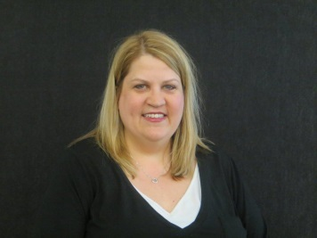
Alpha Phi

Debra Howland Burgess
University of Kansas – Bachelor of Arts emphasis in Organizational Communications

Debra is currently the Contact Center Leader for Synchrony Financial, where she leads a team of over 200 people in Merriam, KS and Charlotte, NC. She has been with the company for 25 years and received many accolades including her work with starting a call center in Hyderabad, India. She has recently been named a finalist for a Stevie Award, Contact Center Leader of the Year. She is a board member and former Chairman of SIDS Resources, an organization dear to her and a refuge after her 7 ½ month old son, Logan died of SIDS in 2008. Since then, she has helped raise over $150,000 in the last 7 years with an annual golf tournament. She has been active in the local Alpha Phi Alumnae Chapter for over 10 years.

Alpha Sigma Alpha

Michelle McMillan
Emporia State University – BSB/Medical Emphasis
I have loved being part of a sorority ever since the day I joined Alpha Sigma Alpha in 1980. In the past, have served on the National Foundation and currently serve on the executive board of the KC Alpha Sigma Alpha Alumni Chapter along with serving as Chapter Advisor for Epsilon Epsilon in Emporia, KS.

Alpha Xi Delta

Leslie Nelson, CTC
University of Iowa – BA Journalism

Leslie has been a travel agent for nearly 25 years, selling both corporate and vacation travel. She is considered a premier expert (Travel Insider) for Dubai by American Express nationwide. She is currently the president of the Greater Kansas City Alumnae Association and has been a member/board member of AA’s in Chicago, Cedar Rapid and Newport Beach as well. She also serves as the secretary for FAUSA, a national organization designed to support women who have repatriated to the United States after having lived overseas. While living in Dubai Leslie also served as the Communications Director for the American Women’s Association. And she has recently taken on the role of Wine Guide for Traveling Vineyard, an in home wine tasting company.

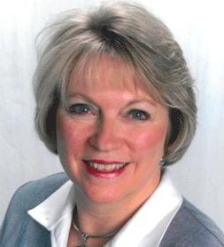
Chi Omega

Kathi Anderson Oppold
University of Iowa – BBA, Business/Marketing, 1973

My career has been a combination of business settings and Mom/Grandma. I’ve worked in banking and for a major financial services group, been a meeting leader and corporate assistant for Weight Watchers International, worked as the Marketing Communication Program Assistant at the KU Edwards campus, and was the primary administrative assistant at a local church office. Mixed around those have been various direct sales businesses and network marketing companies, including one I currently represent as a marketing affiliate. I’m passionate about helping people live their best life, with better health and positive inspiration. Along with being on the Greater Kansas City Chi Omega Alumnae Board, I’m a member, Ambassador and on the Board of Directors of the Lenexa Chamber of Commerce. I’m active in my Church community and volunteer at my grandkids school. I’m married to Mark for 40+ years.

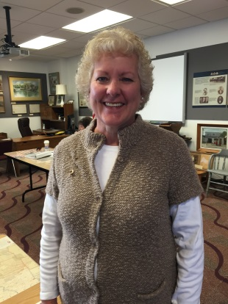
Delta Delta Delta

Laurie Tourtellot
University of Missouri – Columbia – BA Spanish BJ News and Editorial Journalism

Laurie was initiated in 1975 by the Delta Xi Chapter of Delta Delta Delta at the University of Missouri. She has been an active member of the alumnae chapter since graduation. She has served in many positions, including vice-president, treasurer, chairman of the Art Auction, and Panhellenic Representative for the past eight years. At her first Panhellenic Brunch she sat with a group of Alpha Delta Pi’s and learned of a reunion weekend they held for their sisters at their chapter house. She was inspired to organize the same for a group of Tri Deltas from the mid-seventies and a wonderful time was had by all! Laurie works as a Customer Service Representative for the Internal Revenue Service on the nightshift, but willingly forfeits sleep to get up early to attend the Panhellenic meetings!

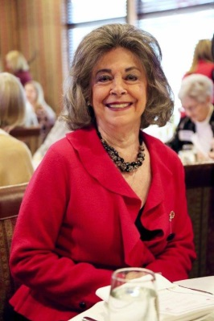
Delta Gamma

Lucinda Rice-Petrie
Missouri University at Columbia – BS Education, 1969, MA American History, 1972

Lucinda Rice Petrie is, quite simply, the embodiment of the Delta Gamma philosophy. She has been a Fraternity leader and award recipient at both the local and national level, receiving three of the highest honors our Fraternity bestows the Cable, Loyalty and Oxford award. Lucinda’s resume contains an impressive array of educational, cultural and philanthropic pursuits. Of particular note are her leadership positions with the Kansas City Young Matrons, the Historic Kansas City Foundation and her role as founder and chairman of Mu Chapter’s Delta Gamma Foundation Lectureship in Values and Ethics at the University of Missouri. Her boundless energy and passion have not only propelled our Fraternity to greater heights, but the Kansas City community as well.

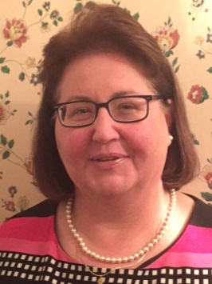
Delta Zeta

Kathleen (Katie) Schatte
University of Missouri Kansas City
University of Kansas

Katie Schatte has spent her life fostering faith, family and a passion to advocate for children. Thanks to her programming and vision as Safe Kids Coordinator for the Johnson County Department of Health and Environment, they were honored as the 2014 Kansas Coalition of the Year. She is on the Safe Kids Kansas board. She was past Board Chair for the local children’s nonprofit Charlie’s House, supporting the organization since 2007. Her leadership includes scouting, where she’s on Troop Committee for Boy Scout Troop 257; teaching CCD for first graders; and serving as Project Co-Chair and Project Chair for the Pilot Club of Shawnee Mission and Kansas-Missouri District. She lives with her husband, David , and son, Andrew.

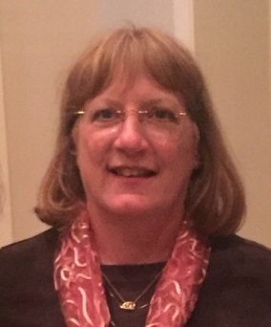
Gamma Phi Beta

Cindy Wood
University of Missouri – Columbia BSEd. English 7-12; Spanish K-12 – 1980
University of Missouri – Kansas City MA Curriculum & Instruction, English 1990

Cindy was initiated into Alpha Delta chapter of Gamma Phi Beta in 1977. She volunteered at the Antiques, Garden & Home Design Show for the Greater KC Alumnae Chapter from 1977 through its end in 2006. She has served on the Affiliated House Corporation Board for the Alpha Delta chapter since 2005. She has served as president of the AHC and currently serves as vice-president. She served as president when the chapter underwent a $750,000 capital campaign to completely renovate the chapter house. On the Greater KC alumnae board, Cindy serves as the representative for the Alpha Delta chapter and is currently the ex-officio having served for two years as the president of the alumnae chapter. Cindy received the IIKE award in 2011 and WOY award in 2015.

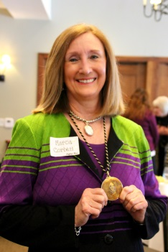
Kappa Alpha Theta

Marcia Corbett
University of Missouri – Recreation and Park Administration
New York University – Paralegal

Graduated from MU with a degree in Recreation and Park Administration, and worked as a research analyst in the economics division of Midwest Research Institute. There she performed an independent study on camper interest in organized camp settings. The results were published in a national magazine and brought attention to the projects underway at MRI. Later she earned a paralegal degree from NYU and specialized in estate planning. After working in law firms for several years she started her own senior advocacy business in 1998 and has been helping older people with legal, financial and medical issues ever since. In 2012 she earned the registered tax return preparer designation from the IRS.

Kappa Delta

Kristy Ladd
Drury University – BA Administration and Music

Kristy Ladd graduated from Drury University in 2010. During her collegiate experience she held multiple leadership roles in the Alpha Psi Chapter of Kappa Delta including chapter President and Panhellenic Recruitment Counselor. Kristy is now a Chapter Advisory Board member and advises VP – Community Service at Zeta Epsilon Chapter at KU and is on the Kansas City Kappa Delta Alumnae Board. Being a Kappa Delta has come full circle for Kristy as she now works for one of Kappa Delta’s national philanthropies, Girl Scouts. She spends her days documenting and telling the Girl Scout story for Girl Scouts of NE Kansas and NW Missouri as Brand Manager, Girl Experience. In her free time Kristy enjoys training and competing in Triathlons, supporting the Royals, being “dog mom” to Baxter and planning her upcoming wedding!

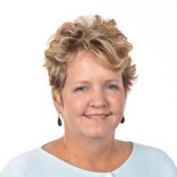
Kappa Kappa Gamma

Nan Vail
Kansas State University – BA
Naval Post Graduate School – MA IT

Nan is a K-State grad who was president of her Kappa Kappa Gamma chapter. She lived many places with an Army General for a father. She followed in his footsteps by serving in the army as an information technology specialist. Nan has been highly involved with the Women’s Employee Network here in KC. She was the 2015 Kappa Loyalty Award recipient and has been an outstanding leader, supporter of our alumnae activities and is currently a national officer.

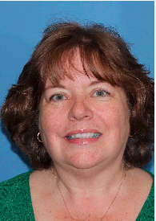
Phi Mu

Connie Fothergill- Deel
Baker University – BS & MLA

Connie is the Chief Human Resources Officer at Baker University. She loves being part of the community of excellent employees at Baker. She and husband Roy have three children and two granddaughters. She was an advisor for Zeta Alpha Chapter of Phi Mu for 30 years, 14 as chapter advisor. Connie has served on the ZA Corporation Board and is on the ZA Chapter Association Board. She received the Outstanding Advisor of the year at Baker. She loves playing with her children and grandchildren, quilting and taking her Phi Mu mother to all of the Baker Women’s Basketball games; GO BU!

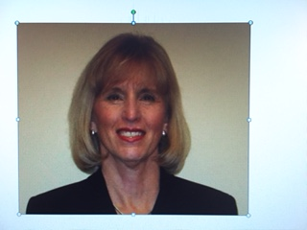
Pi Beta Phi

Becky Akin-Larsen
Arizona State University – BA Education, MA English

Becky pledged Pi Phi at the newly colonized AZ Beta Chapter in 1965. Becky moved to KC area in 2000. She has served as: Publicity, Awards, Theater Tour and Membership Chairman, and President of KCMO/SMKS Alumnae Club. Becky instituted many wonderful programs including the R.E.A.D dog program. Becky is passionate about increasing literacy. Becky has served as Past President as well, and gave immeasurable insight to the incoming President. Becky chaired the Scholarship Committee in a clear and conscious manner, being mindful of technology an seeking new ways to reach prospective applicants.

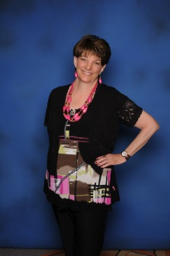
Sigma Kappa

Joyce Lake
Missouri State University – BS Elementary Education

I was born in Chicago, Il, lived in Denver until I was 11, and then moved to Springfield, Mo. I graduated from Missouri State University with a degree in Elementary Education. I moved to Kansas City and taught kindergarten and first grade in North Kansas City and Center districts. I married Steve Lake, and had a son and a daughter, and stayed home with them for 19 years. WE moved back to Kansas City and lived in Stilwell, Ks for 30 years. Since I lived at home during college, Sigma Kappa was a life-line for me! I was very reserved then, and being in the sorority helped me connect with many other people.

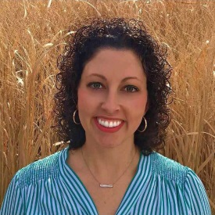
Sigma Sigma Sigma

Ashley Adorante
Fort Hays State University – BS Physical Education
The University of Kansas – Med Community Health

Ashley embodies the Tri Sigma spirt as evidence by service to her sorority. She has served as the President of the Kansas City Alumnae Chapter of Sigma Sigma Sigma for the past 2 years and is also currently serving as the Alumnae Relations Chair, on the Chapter Advisory Board, for the Alpha Gamma Chapter of Sigma Sigma Sigma at Fort Hays State University. This summer Ashley will represent the Kansas City Alumnae Chapter by serving as a voting delegate at the Tri Sigma National Convention in Chicago.

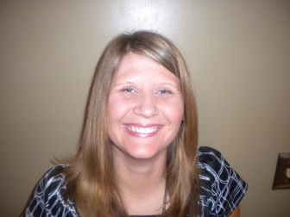
Zeta Tau Alpha

Jennifer Hull
University of Kansas – BA Human Development and Family Life, MS Education

Jenn was born and raised in Emporia and was a member of the ZTA colony at the University of Kansas. After the colony closed, she was initiated into ZTA at Washburn University. Jenn is the epitome of our fraternity’s tradition of serving those within and without our circle. To honor our national philanthropy, breast cancer education and awareness, Jenn has been a volunteer for the Kansas City Race for the Cure for over 10 years, serving as overall race chairman for the 2014 and 2015 races. You can find Jenn at almost every run or walk that benefits a worthy cause in Kansas City. With hundreds of hours of involvement, she quietly serves our sisterhood and community with dedication and love.

